Задача 4. Вычислить приближенно с помощью дифференциала.
4.1. 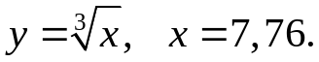
x₀= 8
∆x= 7,76-8= -0,24
f(x₀)= ³√8=2
f'= 1/(3³√х²)
f'(x₀)= 1/(3*4)=1/12
f(x)= 2-0,24/12= 1,98

4.2. 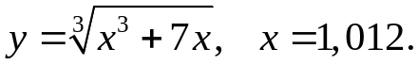
x₀= 1
∆x= 1,012-1= 0,012
f(x₀)= ³√(1+7)= 2
f'= (3х²+7)/(3³√(х³+7х))
f'(x₀)= (3+7)/(3*2)= 5/3
f(x)= 2+0,06/3= 2,02

4.3. 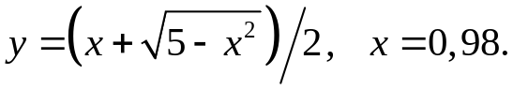
x₀= 1
∆x= 0,98-1= -0,02
f(x₀)= 1/2*(1+√4)=3/2
f'= 1/2-х/(2√(5-х²))
f'(x₀)= 1/2-1/4=1/4
f(x)= 3/2-0,02/4= 1,495

4.4. 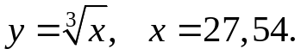
x₀= 27
∆x= 27,54-27= 0,54
f(x₀)= 3
f'= 1/(3³√х²)
f'(x₀)= 1/27
f(x)= 3+0,54/27= 3,02

4.5. 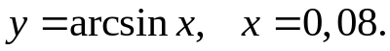
x₀= 0
∆x= 0,08
f(x₀)= arcsin0=0
f'= 1/√(1-х²)
f'(x₀)= 1
f(x)= 0+0,08=0,08

4.6. 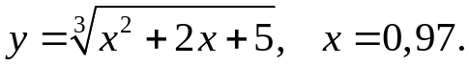
x₀= 1
∆x= 0,97-1= -0,03
f(x₀)= ³√8=2
f'= (2х+2)/3³√(х²+2х+5)
f'(x₀)= 4/(3*2)=2/3
f(x)= 2-0,06/3= 1,98
4.7. 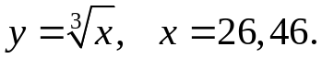
x₀= 27
∆x= 26,46-27= -0,54
f(x₀)= ³√27=3
f'= 1/(3³√х²)
f'(x₀)= 1/27
f(x)= 3-0,54/27= 2,98
4.8. 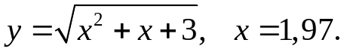
x₀= 2
∆x= 1,97-2= -0,03
f(x₀)= √(4+2+3)
f'= (2х+1)/2√(х²+х+3)
f'(x₀)= 5/(2*3)= 5/6
f(x)= 3-0,15/6= 2,975
4.9. 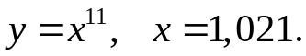
x₀= 1
∆x= 1,021-1= 0,021
f(x₀)= 1
f'= 11х¹⁰
f'(x₀)= 11
f(x)= 1+11*0,021= 1,231
4.10. 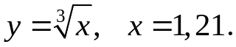
x₀= 1
∆x= 1,21-1= 0,21
f(x₀)= 1
f'= 1/(3³√х²)
f'(x₀)= 1/3
f(x)= 1+0,21/3= 1,07
4.11. 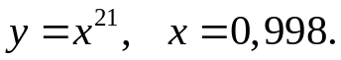
x₀= 1
∆x= 0,998-1= -0,002
f(x₀)= 1
f'= 21х²⁰
f'(x₀)= 21
f(x)= 1-0,002/21= 0,9999
4.12. 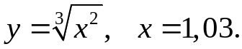
x₀= 1
∆x= 1,03-1= 0,03
f(x₀)= 1
f'= 2/(3³√х)
f'(x₀)= 2/3
f(x)= 1+0,03*2/3= 1,02
4.13. 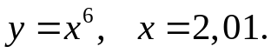
x₀= 2
∆x= 2,01-2= 0,01
f(x₀)= 2⁶=64
f'= 6х⁵
f'(x₀)= 6*2⁵=192
f(x)= 64+0,01*192= 65,92
4.14. 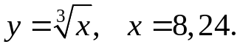
x₀= 8
∆x= 8,24-8= 0,24
f(x₀)= ³√8= 2
f'= 1/(3³√х²)
f'(x₀)= 1/12
f(x)= 2+0,24/12= 2,02
4.15. 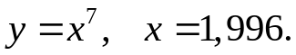
x₀= 2
∆x= 1,996-2= -0,004
f(x₀)= 2⁷=128
f'= 7х⁶
f'(x₀)= 7*2⁶= 448
f(x)= 128-0,004*448= 126,208
4.16. 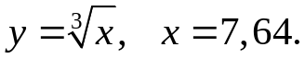
x₀= 8
∆x= 7,64-8= -0,36
f(x₀)= ³√8= 2
f'= 1/(3³√х²)
f'(x₀)= 1/12
f(x)= 2-0,36/12= 1,97
4.17. 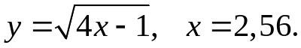
x₀= 2,5
∆x= 2,56-2,5= 0,06
f(x₀)= √(10-1)= 3
f'= 1/√(4х-1)
f'(x₀)= 1/√9= 1/3
f(x)= 3+0,06/3= 3,02
4.18. 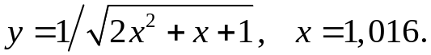
x₀= 1
∆x= 1,016-1= 0,016
f(x₀)= 1/√(2+1+1)= 1/2
f'= -(4х+1)/2√(2х²+х+1)³
f'(x₀)= (-4-1)/2√(2+1+1)³= -5/16
f(x)= 0,5-0,08/16= 0,495
4.19. 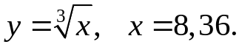
x₀= 8
∆x= 8,36-8= 0,36
f(x₀)= ³√8= 2
f'= 1/(3³√х²)
f'(x₀)= 1/12
f(x)= 2+0,36/12= 2,03
4.20. 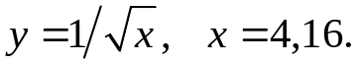
x₀= 4
∆x= 4,16-4= 0,16
f(x₀)= 1/2
f'= -1/(2√х³)
f'(x₀)= -1/16
f(x)= 0,5-0,16/16= 0,499
4.21. 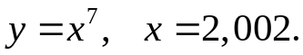
x₀= 2
∆x= 2,002-2= 0,002
f(x₀)= 2⁷=128
f'= 7х⁶
f'(x₀)= 7*2⁶= 448
f(x)= 128+0,002*448= 128,896
4.22. 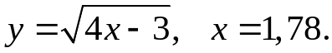
x₀= 1
∆x= 1,78-1= 0,78
f(x₀)= √(4-3)= 1
f'= 2/√(4х-3)
f'(x₀)= 2
f(x)= 1+0,78*2= 2,56
4.23. 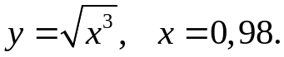
x₀= 1
∆x= 0,98-1= -0,02
f(x₀)= 1
f'= 3/(2√х)
f'(x₀)= 3/2
f(x)= 1-3*0,02/2= 0,97
4.24. 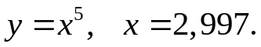
x₀= 3
∆x= 2,997-3= -0,003
f(x₀)= 243
f'= 5х⁴
f'(x₀)= 5*81= 405
f(x)= 243-405*0,003= 241,785
4.25. 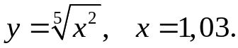
x₀= 1
∆x= 1,03-1= 0,03
f(x₀)= 1
f'= 2/(5⁵√х³)
f'(x₀)= 2/5
f(x)= 1+2*0,03/5= 1,012
4.26. 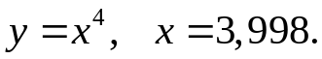
x₀= 4
∆x= 3,998-4= -0,002
f(x₀)= 256
f'= 4х³
f'(x₀)= 4*64= 256
f(x)= 256-256*0,002= 255,488
4.27. 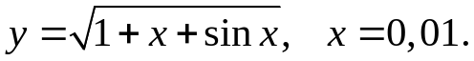
x₀= 0
∆x= 0,01-0=0,01
f(x₀)= √(1+0+sin0)=1
f'= (1+cosx)/(2√(1+х+sinx))
f'(x₀)= (1+1)/2= 1
f(x)= 1+0,01= 1,01
4.28. 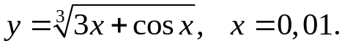
x₀= 0
∆x= 0,01-0= 0,01
f(x₀)= 1
f'= (3-sinx)/(3³√3x+cosx)
f'(x₀)= 3/3= 1
f(x)= 1+0,01= 1,01
4.29. 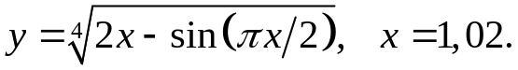
x₀= 1
∆x= 1,02-1= 0,02
f(x₀)= ⁴√(2-1)= 1
f'= (2-π/2*cos(πx/2))/(4⁴√(2x-sin(πx/2)))
f'(x₀)= 2/4√1= 0.5
f(x)= 1+0,02*05= 1,01
4.30. 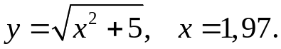
x₀= 2
∆x= 1,97-2= -0,03
f(x₀)= √9=3
f'= х/√(х²+5)
f'(x₀)= 2/3
f(x)= 3-0,03*2/3= 2,98
4.31. 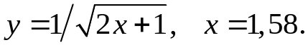
x₀= 1,5
∆x= 1,58-1,5= 0,08
f(x₀)= 1/2
f'= -1/(√(2х+1))
f'(x₀)= -1/2
f(x)= 0,5-0,5*0,08= 0,46

